**KNOWLEDGE ORGANISERS**

**A LEAFLET FOR PARENTS/CARERS**

**Knowledge Organisers: A summary!**

A summary of the most important bits of a topic! Keep it simple and have fun!

Helps children remember more and makes links Keeps children interested

Practice is perfect! (Well not quite but it helps ) You have to use it not just own one!

**What is a knowledge organiser?**

* A knowledge organiser is a document that has lots of key facts, dates and knowledge that your child will need to have a basic knowledge and understanding of a topic.  A knowledge organiser will not include every possible fact on a topic; it will include facts needed to understand the main points.

***You will see:***

1. Key vocabulary
2. Important dates
3. A time line
4. Sticky knowledge
5. Information about important people!

* All the information helps your child get ahead and understand the knowledge so they can use it!

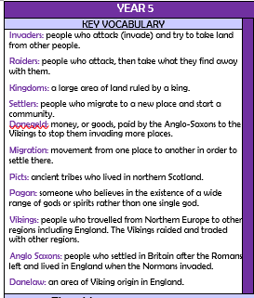 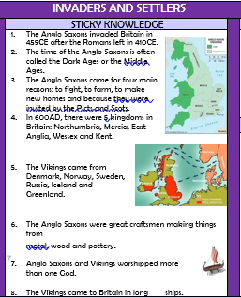 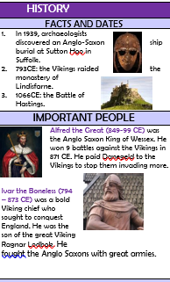

VOCABULARY STICKY KNOWLEDGE FACTS AND DATES

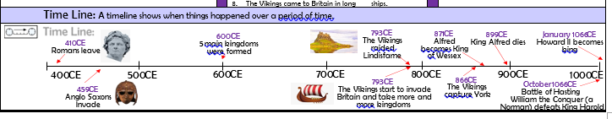

TIMELINE

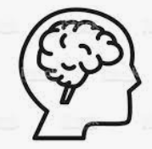**Why are knowledge organisers good for learning?**

* Research shows that our brains remember things better when we know the ‘bigger picture’ and can see the way that ‘nuggets’ of knowledge link together. Making links helps information move into our long-term memory. A knowledge organiser shows linked facts.
* Children understand a topic much better when they have lots of knowledge about it!
* Having knowledge helps keep children interested.
* Knowledge organisers can be used for ‘retrieval’ practice (practising remembering things!). Regular practice at remember (retrieving) knowledge helps us remember more over time and puts the information into our long term memory.
* Knowledge organisers make knowledge clear. So, even if a learner misses a lesson it helps them catch up.

**How can you best use your knowledge organiser?**

There are many ways you can use a knowledge organiser.  The most important thing to say, however, is ‘use it’.

***Owning a knowledge organiser does not make your child remember facts! They have to practice!***

There will be mistakes – this is how we learn.  Also, try different ways of practice. Ultimately, the best way to remember things is to try and remember facts that you can’t quite remember instantly… practise, practise and practise!

**Here are some fun ways you could try to improve your long-term memory. Some are better for Years 5 and 6 but start simple and keep it fun. We will teach children in school how to do the activities during this term.**

|  |
| --- |
| **Hide and Seek**  Children can:   * Read through a small section of your knowledge organiser (three or four key words), cover the facts and try to write out as much as you can remember. Check your answers and correct them if needed.  Then choose your next words or check ones you have already done again.   ***Hide it and write it or hide it and say it!*** |
| **Brain Dumps**   * Give your child a few minutes to write down (or draw) everything |
| **Quiz**   * Write questions for your child or ask them to write their own questions for a particular section of a knowledge organiser.  They must write the answer or the question from memory.  Check and correct using the knowledge organiser. * Maybe have fun and make it a game with you- 2 points for every question answered correctly without checking and one for checking and finding the answer! Maybe every point is a Smartie or a grape, or a minute playing their favourite game with you! |
| **One minute challenge!**   * After reading and practising with their knowledge organiser ask your child to spend one minute telling someone everything you know about the topic. You could video it and send it one DOJO or watch it again and then try and remember more another time. Is the second video better? |
| **Back to front**   * Write down a fact from memory and then compose a question that would lead to that answer. |
| **Sketch it**  Children can:   * Draw pictures /diagrams to represent each of the facts or dates (time lines, flow diagrams, or labelled pictures are great ways of remembering parts of a system or orders of events). |
| **Put it in a Sentence**   * Ask your child to take a key word and create a sentence that uses it. |
| **Mnemonics**   * Create a sentence where each word starts with the first letter of a key word to help remember lists. So, Elephants Always Drive Green Busses Everyday helps you remember the strings of a guitar E A D G B E |
| **Teach it!**   * Teach and explain to someone your key facts – you could even test them! |
| **Repackage it: Mind maps**  Your child can:   * Choose a key question or topic. Write it in the centre of the piece of paper. * Note down what the main points or key principles are. * Note down the sub-ideas/definitions on your mind map. * How do each of the ideas link together? Can you add that to your diagram? * Check and correct using the knowledge organiser. |
| https://www.emmanuel.nottingham.sch.uk/wp-content/uploads/sites/9/2019/09/Screenshot-2019-09-19-at-09.11.25-1024x762.jpg**Clock learning**   * Help your child to draw a simple clock with 12 sections.   Either:   1. Children write an important piece of knowledge in each section 2. Together divide the topic up into 12 chunks (Dates, facts, people, houses, food, battles etc)   Spend five minutes noting down everything that you know in that section.   * Help your child check answers using the knowledge organiser |
| **Flashcards**   * Children can make their own flashcards for testing/quizzing. * On one side write the question or write a word * On the other side write the answer or the definition of the work. * Try and answer the questions without looking or checking first- then check you are right. * You could play a game- how quickly can your child answer all the questions…. Can they beat their time! |
| **Test, Read, Cover, Check**   * Your child writes down everything they already know about this topic. * They have 5 minutes to study the knowledge organiser in SILENCE. * Turn the knowledge organiser over and FROM MEMORY they write down EVERYTHING they remember. * Your child then checks against the information on your knowledge organiser. Tick what you got. Together work out, what did you miss out? * Add 3 ideas that were missed out. |
| **Find out more!**  Help your child to search on the internet about the topic. Use a safe search engine or parent controls if you are not with them.  <https://www.safesearchkids.com/> |
| **Always get your child to check your answers and correct anything they got wrong…. Everyone is allowed to get things wrong… That is how you learn!** |

**THANK YOU FOR YOUR SUPPORT**

